**ERD DIAGRAMS**

**ASSIGNMENT 1*: TechShop***

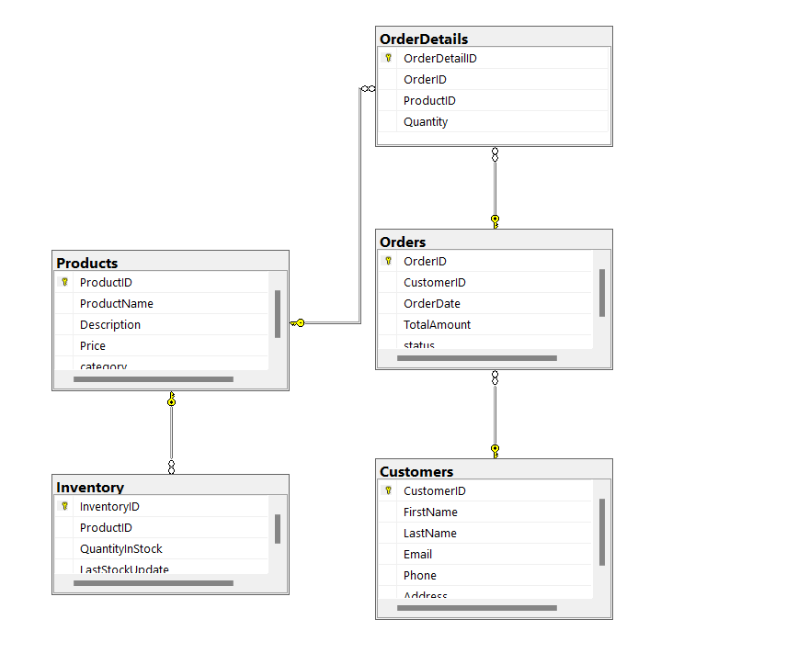

***ASSIGNMENT 2: SISDB***

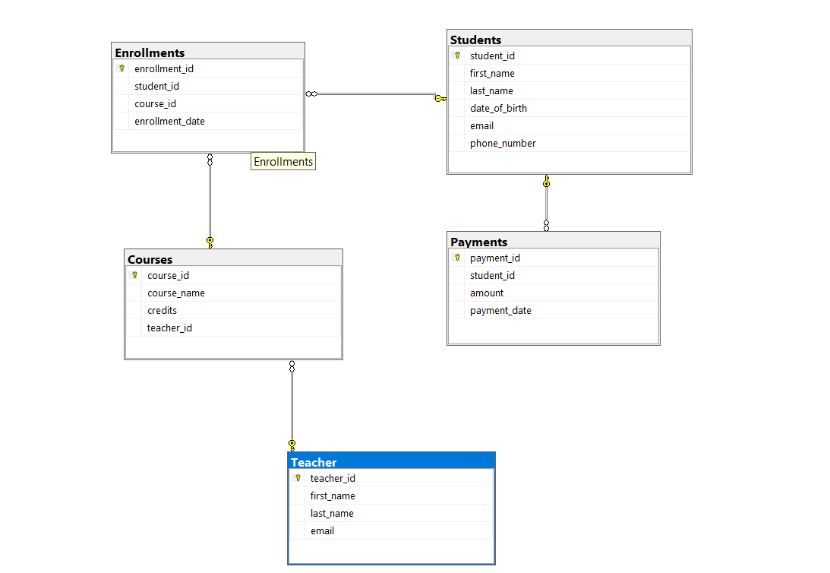

***ASSIGNMENT 3: HMBank***

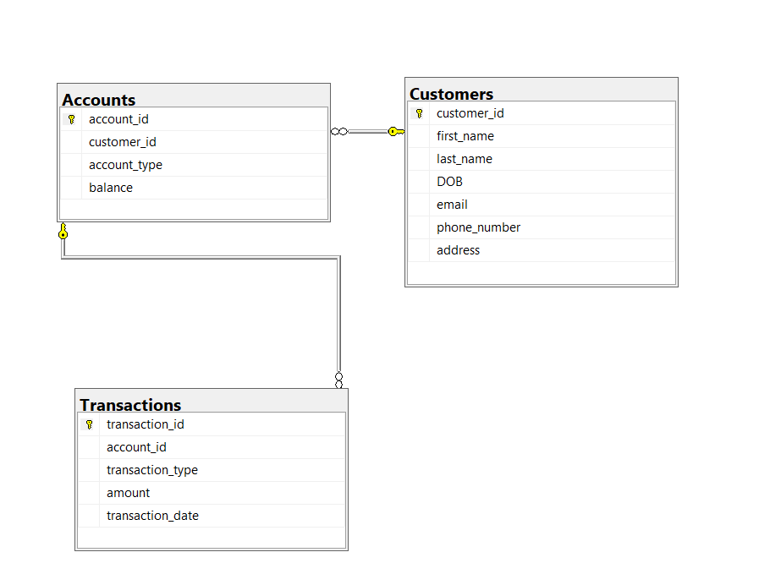

***ASSIGNMENT 4: CourierManagementSystem***

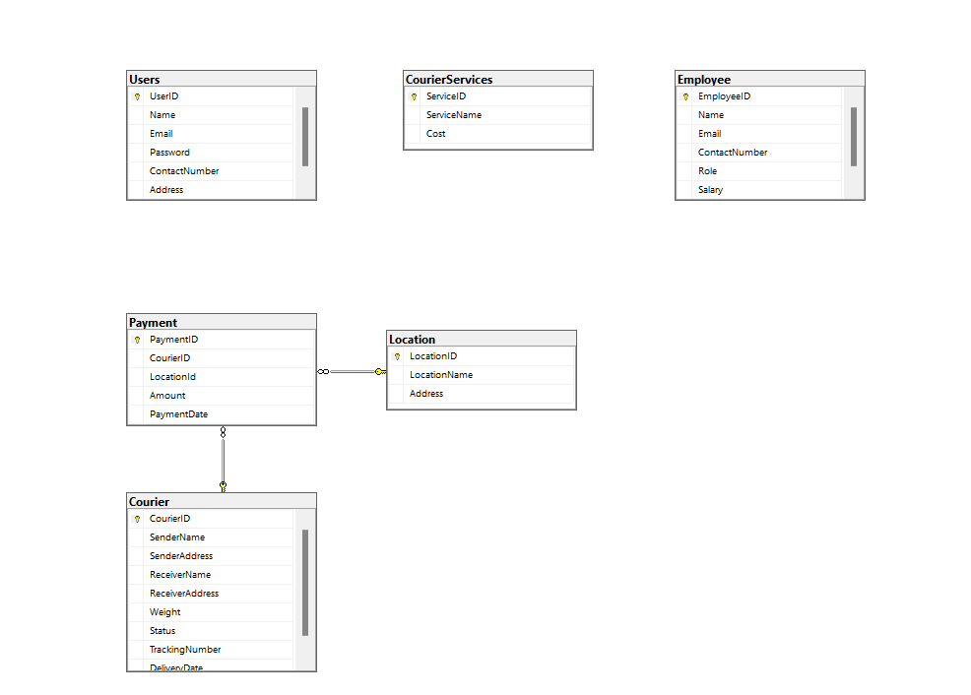

***ASSIGNMENT 5: TicketBookingSystem***

